***Warner***

***Family Tree***

Name: Edgar Wenham Warner (1842- 1915)

m. Name : Louisa Matilda Ribbins Married – June 3rd 1876 St George the Martyr, Surrey, Southwark, England

**No children**

Name Edgar Wenham Warner

(parents – John Menzies Warner ( 1818-1887) and Sarah Cassandra Hill ( 1813-1885)

Born – December quarter 1842, Stepney, London England

Died – June 1915, Romford, Essex, England

Aged – 73

Buried – Essex, England

Married: on 3rd June 1876

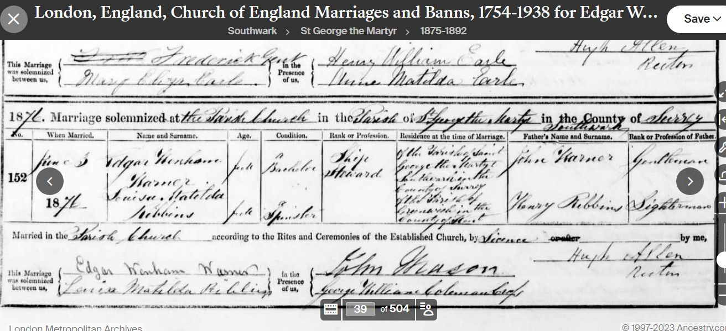

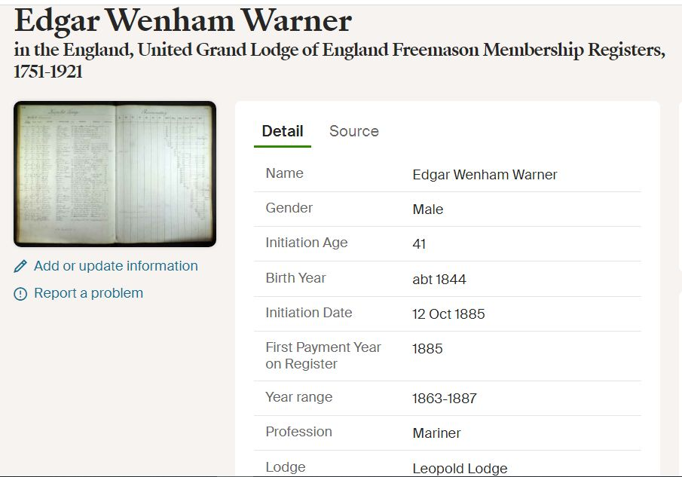

Name : Louisa Matilda Ribbins

Born – 1849 Greenwich, Kent, England father Henry Ribbins

Died – Unknown

Aged –

Buried -

Time Line for Edgar Wenham Warner

1842 Born Stepney London,

1851 Living with parents in Middlesex England

1861 No Census record . At sea?

1865 On “City of Adelaide” July from London to Pt Adelaide as second steward

1866 Return to London on “City of Adelaide” in December- second steward

1870 On May voyage of “City of Adelaide” as second steward, to Port Adelaide

1871 Not in Census in England- at sea?

1871 Louisa working in home of George Warner as a domestic servant.- probably how they met.

1876 Married Louisa Ribbins in England

1881 At brother in law’s house (George Clark) at Mile End, London , England- visitor- occ steward 39 born Stepney- no

Louisa or children. Louisa working as a domestic servant in Lewisham London (born Greenwich Kent)

1885 Joined Lodge

1891 At brother in law’s house (George Clark) at Mile End, London- occ Steward age 47 No Louisa or children

1901 At St Mary, Stratford-Bow age 58- shipping clerk- No Louisa or children

1911 At Bow, Polar, London age 68 –a shipping clerk. Married no children born. Living with sister Elizabeth Clark

1915 Died Essex, England

1918 a Louisa Matilda Warner died in Lewisham, London – probably her. It seems they may have moved apart.

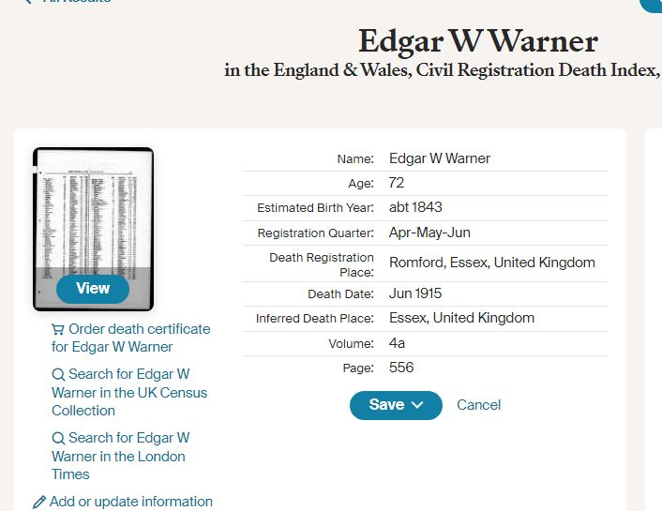

Sources

Ancestry, My Heritage, G.R.O., Family search